Professional Biography
Shawna Coleman (She/Her), Healing Touch Practitioner Alberta (HTPA). Healing Touch is an energy therapy in which practitioners consciously use their hands in a heart-centered and intentional way to support and facilitate physical, emotional, mental and spiritual health.
Cell #403-771-3748 HTTherapywithShawna@gmail.com and Shawna Coleman | LinkedIn
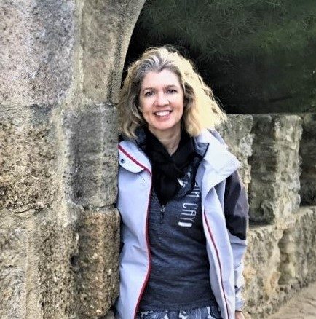
Compassionate | Active Listening | Highly Empathetic
Self-Starter | Organized | Motivated
Grounded | Reliable | Intuitive

Shawna Coleman, as a Healing Touch Practitioner, has 13 years experience working with the human Energetic biofield with over 100 + clients, healing in both clinical and non-clinical settings. Clients have included people presenting with the following issues: Nonverbal children with Asperger and Autism Spectrum, Military veteran with PTSD, Pets with behavioral issues, Hospice, Adults with trauma from unexpected events like the Calgary flooding in 2013.

Shawna’s Energy Medicine Education and training encompasses Healing Touch courses -Levels 1 to 5 (2007 to 2020). Her studies include 130+ hours of Continuing Education with a Board-Certified Instructor Betty Minifie, RN, BSSC, HTCP/I. Betty has guided Shawna as instructor, mentor and coach through both her work experience and her studies. Shawna continues progress on her Certification package, with the goal of being a Board-Certified Practitioner of Healing Touch by mid-2021.

Shawna is a volunteer member of several professional organizations, including Society of Healing Touch Program Alberta (SHTPA), and Director of Bursaries, Canadian Healing Touch Foundation (CHTF). Shawna has also volunteered time with Healing Touch Professional Association (HTPA) in 2020 during ‘Giving Tuesdays’. As well, since 2019 when the pandemic hit the world, Shawna has volunteered 25+ sessions to clients experiencing financial challenges.

Shawna’s heart-centered intention as a Practitioner of Healing Touch, is to help facilitate the client’s health and healing. To restore balance and harmonies in the energy system, placing the client in a position to self-heal.

